# Instructions for EspressoBin-Ultra image

After installing the Linux image in the EspressoBin it’s necessary to make the following changes.

For that Login into the system.

## File Transfer with TeraTerm

These procedures use TeraTerm to transfer files from a Windows system to the EspressoBin.

To use this functionality on the Linux execute command “rz” and on TeraTerm use “Transfer | ZMODEM | Send…”:

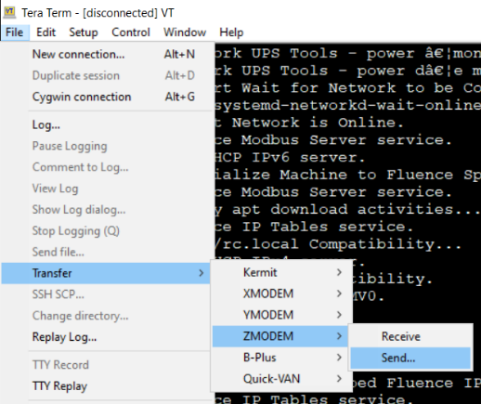

You can transfer multiple files at the same time.

## Updating controllino_modbus Python files

Execute these commands:

1. cd /usr/local/bin
2. rz
3. < Initiate in TeraTerm the sending of files Controllino_Modbus/usr-local-bin/*.py >

1. chmod 777 *.py
2. cd controllino_modbus_utils
3. rz
4. < Initiate in TeraTerm the sending of all files in directory Controllino_Modbus/usr-local-bin/controllino_modbus_utils >

1. chmod 777 *.py

## Updating controllino_modbus.conf file

There are 3 types of Cubes:

Liquid-Cooled Long Duration, Liquid-Cooled Short Duration, and Air-Cooled

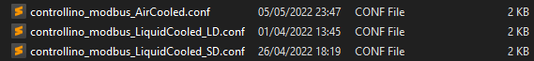

Execute these commands:

1. cd /usr/local/share/fluence
2. rz
3. mv controllino_modbus.conf controllino_modbus.conf.bak
4. < Initiate in TeraTerm the sending of all files in directory Controllino_Modbus/usr-local-share-fluence >

1. Depending on the type of Cube execute one of these commands:

If it is a Liquid-Cooled Long Duration Cube:

cp controllino_modbus_LiquidCooled_LD.conf controllino_modbus.conf

If it is a Liquid-Cooled Short Duration:

cp controllino_modbus_LiquidCooled_SD.conf controllino_modbus.conf

If it is an Air-Cooled:

cp controllino_modbus_AirCooled.conf controllino_modbus.conf

## Updating Self-Configuration files

Execute these commands:

1. cd / home/fos/SelfConfiguration
2. rz
3. < Initiate in TeraTerm the sending of all files in directory Self_Discovery/home-fos-SelfConfiguration >

1. chmod 777 *.py